Multiple-choice section – choose the correct answer

Question 1 [8.1]

Adjacent angles:

A are complementary

B are supplementary

C have a common vertex and a common arm

D are vertically opposite

Question 2 [8.2]

If one angle of a parallelogram is 120°, what are the measurements of the remaining 3 angles?

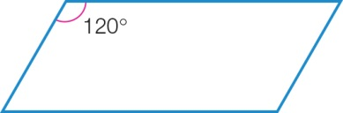

A 60°, 100°, 20°

B 20°, 10°, 30°

C 20°, 10°, 30°

D 60°, 120°, 60°

Question 3 [8.4]

When two triangles have two pairs of sides the same length and the angle formed by the two sides is the same, the two triangles are congruent because of:

A AAS B SAS C SSS D ASA

Question 4 [8.2]

The value of the pronumeral *x* is:

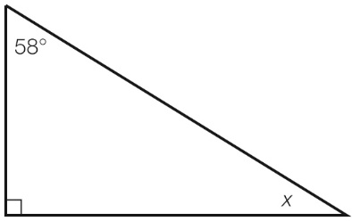

A 148° B 32° C 58° D 212°

Question 5 [8.3]

The quadrilaterals *ABCD* and *PQRS* are congruent. Which side must have the same length as *DC*?

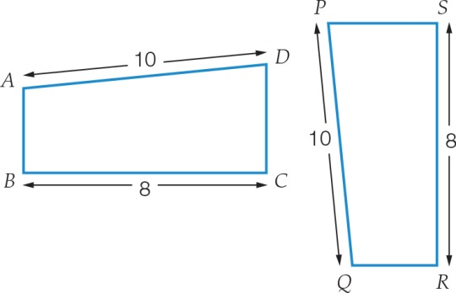

A *AB* B *QR* C *PS* D *SR*

Question 6 [8.3]

The point (2, 5) is a vertex of a kite.

When the kite is reflected in the *x*-axis, what are the coordinates of the image of the vertex?

A (2, -5) B (-2, -5) C (2, 5) D (-2, 5)

Question 7 [8.5]

In a kite, an angle between two sides of different lengths is 98°. Another angle in the kite must be:

A 131° B 98° C 133° D 262°

Question 8 [8.5]

Which statement is true for a rhombus?

A diagonals bisect each other at right angles

B all angles are right angles

C the shape has no side or diagonal properties

D diagonals are parallel

Multiple-choice results: ___ /8

Short answer section

Question 9 2 marks [8.1]

State if each of the following pairs of angles is complementary or supplementary.

(a) 56° and 34° ________________

(b) 18° and 162° ________________

Question 10 3 marks [8.1]

The size of angle *AOC* is 140° and the size of angle *BOD* is 148°.

Find the size of angle *DOC*.

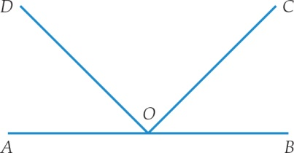

Question 11 2 marks [8.1]

Find the value of the angle *x* in the diagram. Give reasons for your answer.

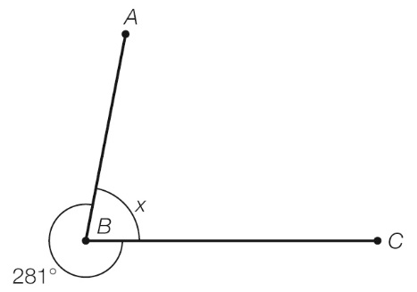

Question 12 4 marks [8.1]

Find the value of the pronumerals in the diagram. Give reasons for your answers.

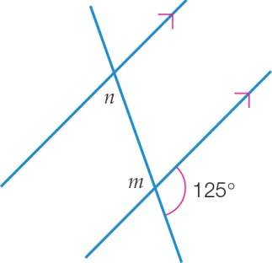

Question 13 2 marks [8.2, 8.3]

Choose the correct words from the following list to fill each of the gaps in the following sentences.

*triangle square rectangle translation reflection rotation*

(a) The exterior angle of a _______________ is equal to the sum of the two opposite interior angles.

(b) Another name for a flip is a ________________.

Question 14 6 marks [8.2]

Find the value of the pronumerals in the diagram. Give reasons for your answers.

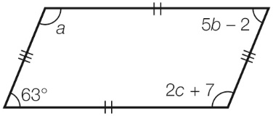

Question 15 2 marks [8.4]

State which of the triangles below are congruent and which test can be used to prove this. Note that diagrams are not drawn to scale so use the markings as your guide.

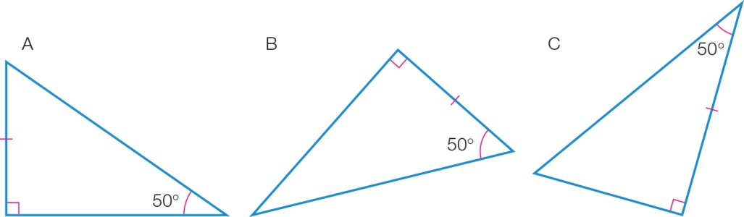

Question 16 2 marks [8.2]

What is the size of each angle in a regular octagon?

Question 17 6 marks [8.3]

(a) Using the grid below, plot the points *A*(-5, 9), *B*(-7, 5), *C*(-4, 2) and *D*(-3, 5). Join the points to form a quadrilateral *ABCD* and label the points.

(b) Perform the translation of [6, -6] on *ABCD*.

(c) Using the shape you created in (b), perform a clockwise rotation of 90° about the point *C*′.

(d) Using the shape you created in (c), perform a reflection in the *y*-axis. What are the coordinates of this transformed quadrilateral?

*A*′′′ ____________ *B*′′′ ____________ *C*′′′ ____________ *D*′′′ ____________

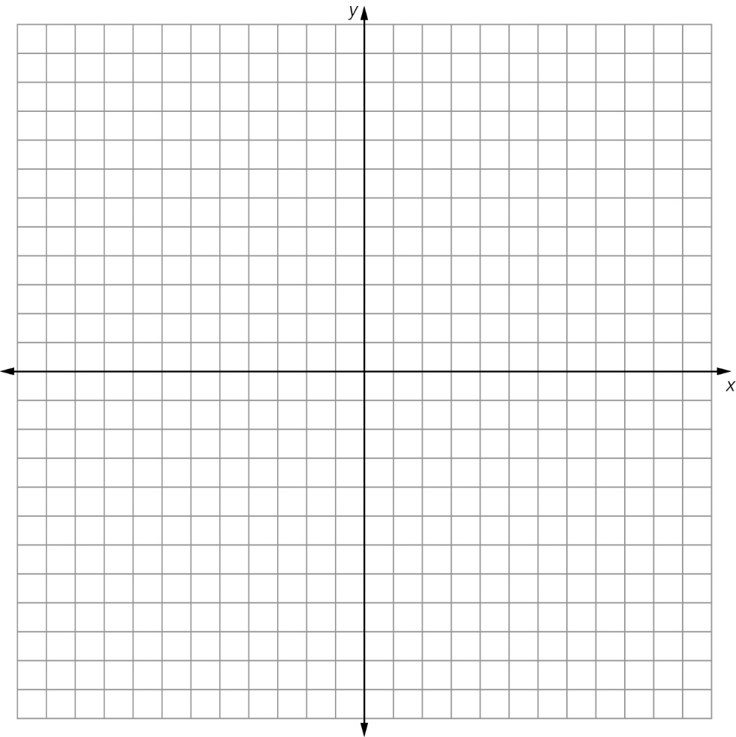

Question 18 4 marks [8.5]

Answer true or falsefor the following statements.

(a) In a rectangle the diagonals are congruent. ______________

(b) A rhombus is a parallelogram with four congruent sides.________________

(c) A rhombus is always a square. _______________

(d) In a square, opposite angles are congruent. ________________

Question 19 3 marks [8.4]

Consider the following pair of triangles.

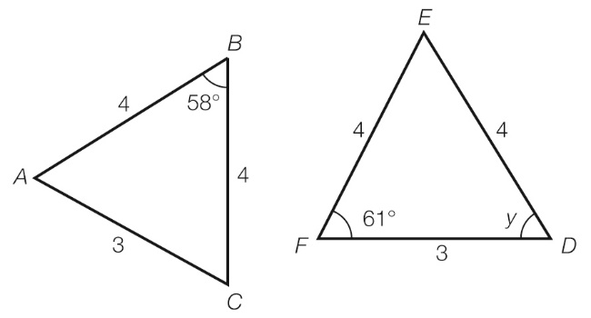

(a) Show that they are congruent.

(b) Find the value of the angle *y*.

Question 20 2 marks [8.5]

Use congruent triangles and known angle facts to find the value of the pronumeral in the quadrilateral. Give reasons for your answer.

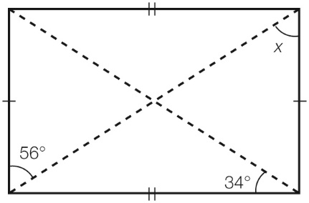

Short answer results: ___ / 38

Extended answer section

Question 21 4 marks [8.2]

A triangle has angles (5*x* – 8)°, (2*x*+ 11)° and (4*x* + 1)°.

Find the size of each angle.

Question 22 5 marks [8.2]

(a) Find the value of the angles *a*, *b* and *c*. Give reasons for your answers.

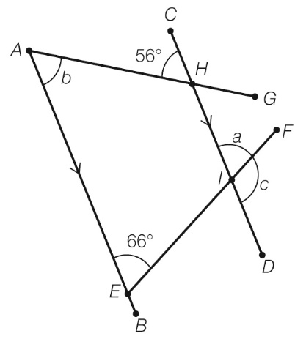

(b) What other angle(s) are equal to ∠*FID* (or *c*)?

(c) What is the size of ∠*AHI*?

Extended answer results: ___ / 9

TOTAL test results: ___ / 55